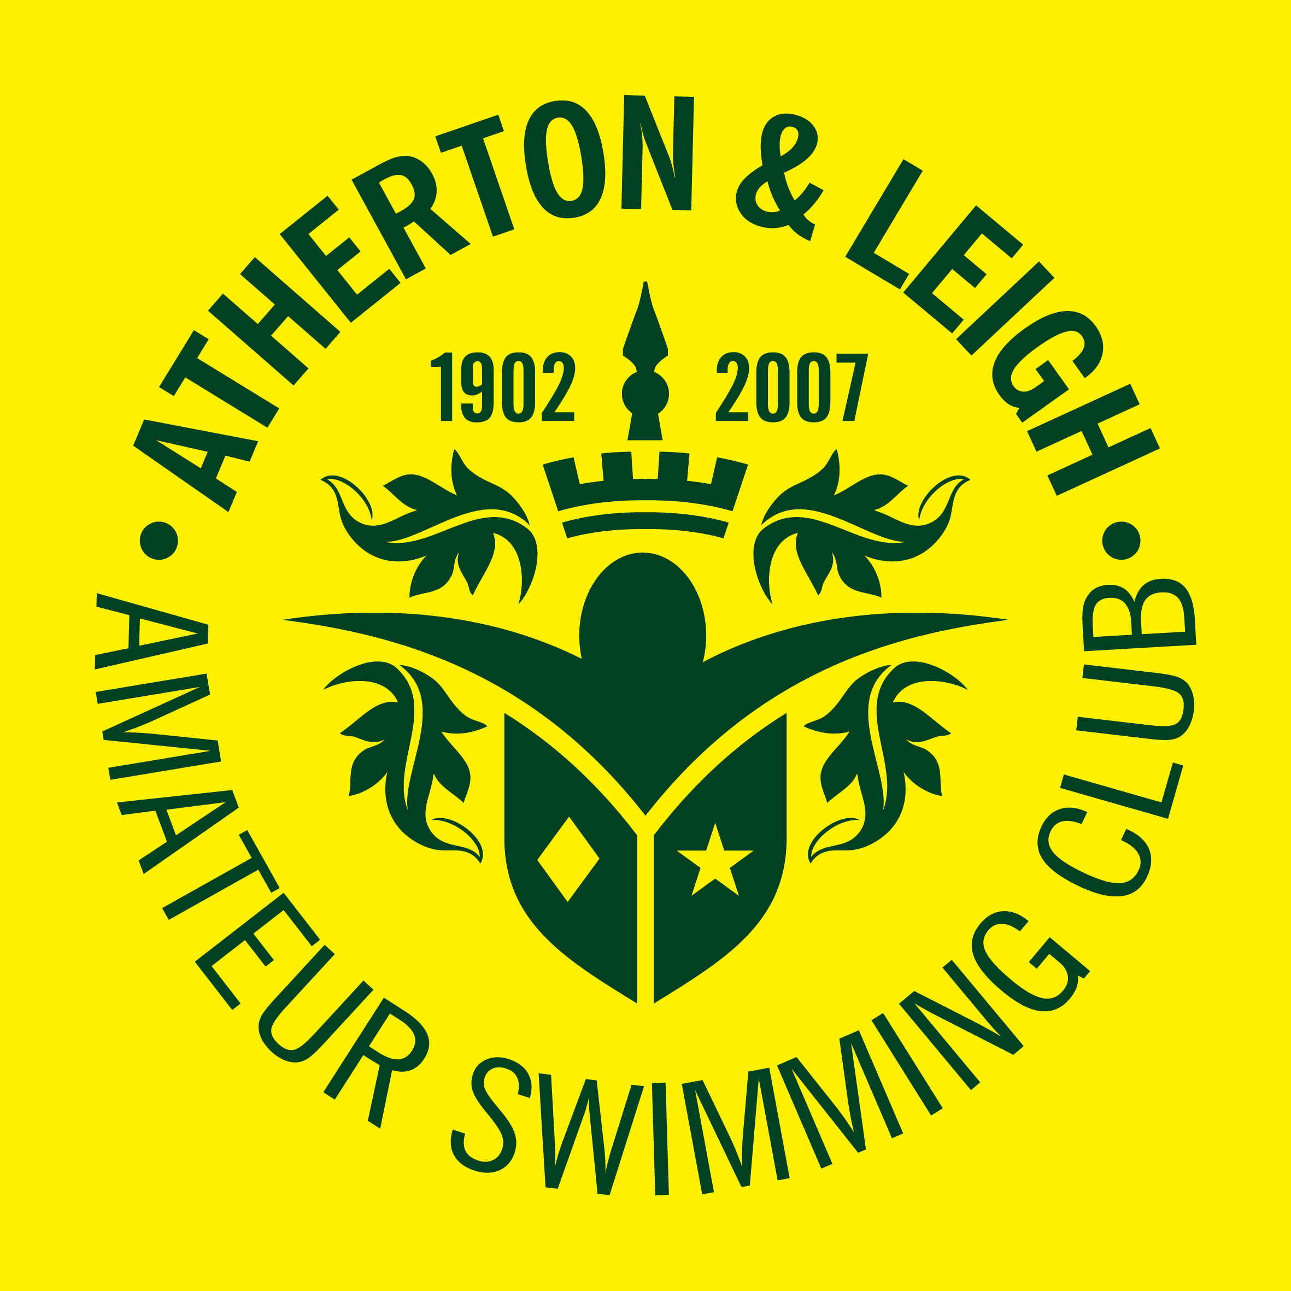

Atherton and Leigh
Amateur Swimming Club
Mission Statement
Atherton and Leigh Amateur Swimming Club's mission is to be recognised as a quality community sports club, promoting the art of swimming.
Atherton and Leigh ASC aims to teach swimming in a safe child friendly environment.
To develop children's water skills and introduce them to appropriate development and competitive pathways, including volunteering in sport. So that swimming provides a life long skill that is fun and supports a healthy lifestyle.
The club aspires to all the principles of the Amateur Swimming Association codes of practice, including child protection, ethics and disability.
Atherton and Leigh ASC also provides links and partnerships with other agencies, local regional and national to support pathways to excellence for it's membership, including swimmers, teachers, coaches, helpers, officials and volunteers. The club values and recognises all their contributions.

